BY-

**Divya Dhande**

**PGDJ 2nd Semester**

**Roll No. 2110002**

**WOMEN PROTECTION IN INDIA**

In Indian society, woman occupies a vital position and venerable place. The Vedas glorified women as the mother, the creator, and one who gives life and worshipped her as Devi or Goddess. Women in India, today, are becoming the most vulnerable section as far as their safety and security is concerned. Violence against women can fit into several broad categories. Some of them are rape, domestic violence, sexual harassment, female infanticide etc.  
  
Our country must have the largest number of laws, ostensibly for the benefit of women. The Constitution and the different Acts passed by the Union Governments and the states give special protection to women, aware of their weak position. In spite of all these pieces of legislation loaded in favour of women, their condition is improving only at a snail’s pace.

## All you need to know the Rights of Women in India:

When we talk about the rights for women in India then we can take into consideration both the Constitutional Rights and Legal Rights. The constitutional rights are those which are incorporated in the various provisions of the constitution. The legal right refers to those which are incorporated in the various laws (Acts) of the Parliament and the State Legislatures.

**Rights of Woman enshrined in the Constitution of India:**

1. **Article 15(1)** provides that the state shall not discriminate against any citizen of India on the ground of sex.
2. **Article 15(3)** provides that the state is empowered to make any special provision for women i.e. the state can make affirmative discrimination in favour of women.
3. **Article 16(2)** provides that no citizen shall be discriminated against or be ineligible for any employment or office under the state on the ground of sex.
4. **Article 23(1)** provides that traffic in human beings and forced labour is prohibited.
5. **Article 39(a)** provides the state to secure for men and women equally the right to an adequate means of livelihood.
6. **Article 39(d)** provides the state to secure equal pay for equal work for both Indian men and women.
7. **Article 39(e)** provides that the state is required to ensure that the health and strength of women workers are not abused and that they are not forced by economic necessity to enter avocations unsuited to their strength.
8. **Article 42** provides that the state shall make provision for securing just and humane conditions of work and maternity relief.
9. **Article 51-A (e)** provides that it shall be the duty of every citizen of India to renounce practices derogatory to the dignity of women.

10. **Article 243-D(3)** provides that one-third of the total number

of seats to be filled by direct election in every Panchayat shall

be reserved for women.

11. **Article 243-D(4)** provides that one-third of the total number

of offices of Chairpersons in the Panchayats at each level shall

be reserved for women.

12. **Article 243-T(3)** provides that one-third of the total number of

seats to be filled by direct election in every Municipality shall be

reserved for women.

13. **Article 243-T(4)** provides that the offices of Chairpersons in the

Municipalities shall be reserved for women in such manner as

the State Legislature may provide.

Legal Rights of Women enshrined under various Indian Legislations:

* **Protection of Women from Domestic Violence Act (2005)** is a comprehensive legislation to protect women in India from all forms of domestic violence by the husband or any of his relatives. Domestic violence is subjected to any kind of physical, sexual, mental, verbal or emotional.
* **The Immoral Traffic (Prevention) Act, 1986 (PITA)** has amended The Immoral Traffic (Suppression) Act, 1956 (SITA). This Act is the premier legislation only for prevention of trafficking for commercial sexual exploitation i.e. for the purpose of preventing and ultimately prohibiting prostitution for women and girls to criminalize sex work. In 2006, the Ministry of Women and Child Development proposed an amendment bill i.e. the Immoral Traffic (Prevention) Amendment Bill, 2006 that has yet to be passed.
* **Indecent Representation of Women (Prohibition) Act (1986)** prohibits indecent representation of women through advertisements or in publications, writings, paintings, figures or in any other manner.
* **Commission of Sati (Prevention) Act (1987)** provides for the more effective prevention of the commission of practice of Sati or the voluntary or forced burning or burying alive of widows, and to prohibit glorification of this action through the observance of any ceremony.
* **Dowry Prohibition Act (1961)** prohibits the giving or receiving of dowry at or before or any time after the marriage from women.
* **Maternity Benefit Act (1961)** protects the employment of women during the time of her maternity and entitles her to a ‘maternity benefit’ and certain other benefits.
* **The Maternity Benefit (Amendment) Act, 2017** an amendment to the Maternity Benefit Act (1961) has been passed. The Act is applicable to contractual or consultant women employees, as well as to the women who are already on maternity leave at the time of enforcement of the Amendment Act.
* **Medical Termination of Pregnancy Act (1971)** provides for the termination of certain pregnancies by registered medical practitioners on humanitarian and medical grounds.
* **Pre-conception and Pre-Natal Diagnostic Techniques (Prohibition of Sex Selection) Act (1994)** prohibits sex selection before or after conception and prevents the misuse of pre-natal diagnostic techniques for sex determination leading to female foeticide.
* **Equal Remuneration Act (1976)** provides for payment of equal remuneration to both men and women workers for same work or work of a similar nature. It also prevents discrimination on the ground of sex, against women in recruitment and service conditions.
* **Muslim Women (Protection of Rights on Divorce) Act (1986)** protects the rights of Muslim women who have been divorced by or have obtained divorce from their husbands.
* **Hindu Succession Act (1956)** recognizes the right of women to inherit parental property equally with men. Then there came the Hindu Succession (Amendment) Act 2005 granting daughters the right to inherit ancestral property along with their male relatives.
* **Minimum Wages Act (1948)** does not allow discrimination between male and female workers or different minimum wages for them.
* **Mines Act (1952) and Factories Act (1948)** prohibits the employment of women between 7 P.M. to 6 A.M. in mines and factories and provides for their safety and welfare.
* **The Sexual Harassment of Women at Work Place (Prevention and Protection) Act (2013)** provides protection to women from sexual harassment at all workplaces both in public and private sector, whether organised or unorganized.
* **Child Labour (Prohibition and Regulation) Amendment Act, 2016** prohibits the engagement of children in all occupations and of adolescents in hazardous occupations and processes, where adolescents refer to those under 18 years and children to those under 14 years.
* **The Protection of Children from Sexual Offences (POCSO Act) 2012** was formulated in order to effectively address sexual abuse and sexual exploitation of children. It defines a child as any person below the age of 18 years and provides protection to all children under the age of 18 years from the offences of sexual assault, sexual harassment, and pornography.

## Apart from the above-mentioned rights, there are following general laws that every woman should know:

* **Right to privacy -** A woman who has been raped has a right to record her statement in private in front of the magistrate without being overheard by anyone else or with a lady constable or a police officer in person. Under section 164 of the Criminal Procedure Code, the cops will have to give the privacy to the victim without stressing her in front of masses.
* **Right to Zero FIR -** As according to the Supreme Court ruling a rape victim can register her police complaint from any police station under the Zero FIR.
* **Right to no arrest -** According to a Supreme Court ruling, a woman cannot be arrested after sunset and before sunrise. Except, in case the woman has committed a serious crime, the police require to get it in writing from the magistrate explaining why the arrest is necessary during the night.
* **Right to not being called to the police station -** According to section 160 of the Criminal Procedure Code, women cannot be called to the police station for interrogation. The police can interrogate a woman at her residence in the presence of a woman constable and family members or friends.
* **Right to confidentiality -** Under no conditions a rape victim’s identity of can be revealed. Neither the police nor media can make known the name of the victim in public. Section 228-A of the Indian Penal Code makes the disclosure of a victim’s identity a punishable offence.

## Recent amendments to certain laws:

* The gang rape that took place on the night of 16th December 2012 took the entire nation in such a outrage stage that it forced to give a new shape to the criminal law by the enactment of the most awaited Act i.e. the Criminal Law (Amendment) Act, 2013 Thus the Act has included the following sections:
* Section 354A provides for Sexual harassment and punishment for sexual harassment.
* Section 354B provides for Assault or use of criminal force to woman with intent to disrobe.
* Section 354C provides for Voyeurism.
* Section 354D provides for Stalking.
* The definition of ‘Rape’ under section 376 has been amended.
* The Muslim Women (Protection of Rights on Marriage) Bill 2017 makes instant ‘Triple Talaq’ in any form ‘illegal and void’. The proposed law would also give the woman the right to approach a magistrate seeking ‘subsistence allowance’ for herself and her minor children.

**WOMEN PROTECTION IN CHHATTISGARH**

# Chhattisgarh State Commission for Women, Raipur

# 

A prosperous and strong society cannot be imagined without the upliftment of women, after the formation of the state of Chhattisgarh in November 2000, the state government has taken many decisions in the interest of women. To empower women in the state, to look after and protect the interests of women, to end the discrimination system against women, to provide them equal opportunities for development in every field and to take prompt action on atrocities and crimes against women. Women's Commission has been established on 24.03.2001.

**Objective of setting up the commission**

The main objectives of its formation are:

* To review the constitutional and legal safeguards of women.
* To recommend remedial legislative measures to the government.
* To facilitate redressal of complaints.
* To advise the Government on all policy matters affecting women.
* Sending suggestions to the government for women's safety and empowerment.
* To take necessary steps for the protection of women.
* To make an in-depth study on the social, economic, educational and health status of women.
* To compile information from time to time on crimes against women.

# Cases registered in the commission and resolved

## Received applications and resolved cases for the year 2017-18 month - March 2018

## https://cgmahilaayog.com/images/prativadan-2017-2018.jpg

**Working Of The Commission**

* Action on representations and complaints received
* hearing of cases
* Hearing camp organized
* Coordination between different departments
* Publicity to create awareness against social evils, evils
* Organize awareness camps
* organize workshop
* Action on letters received from National Commission for Women and other institutions
* taking cognizance of events
* Organizing Meetings and Meetings
* Evaluation and counseling of schemes run for women's welfare
* field trip/study tour

**Structure**

**Nature Of Commission**

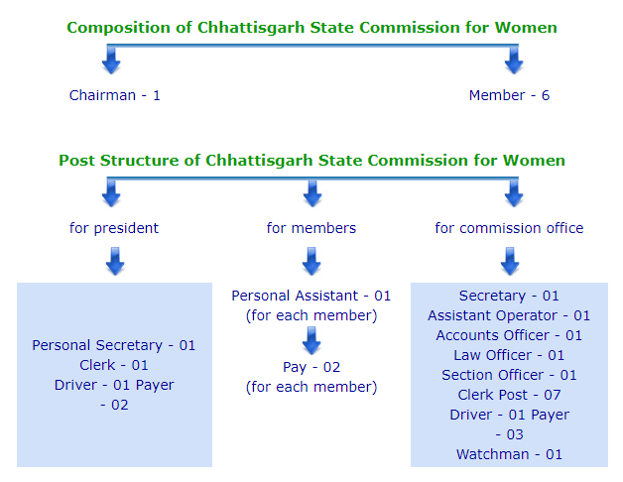

# How To Complain

* Any aggrieved woman of Chhattisgarh state can present her complaint in the State Women's Commission office or make personal contact with the chairman/members or secretary in the commission.
* The aggrieved woman can also send her complaint by post to the State Commission for Women.
* The victim can also send her complaint online or by mail to the commission.
* An affidavit will also have to be given along with the complaint in which it will be mentioned that the case:-
  1. The event must not have occurred for a period exceeding one year.
  2. Not pending before any court.
  3. The complaint is not vague, pseudonymous, anonymous.
  4. The complaint is not of a frivolous nature.
  5. Not outside the scope of the commission's work.

## Admission of representation/complaint

After examination, the complaint is of commission's jurisdiction, being clear and factual, readable, and prima facie credible only if the facts mentioned in the affidavit are valid. shall be accepted by the Chairman/Commission. After the case is admitted, further action is taken.

**Conclusion**

Indian women have had an extremely difficult time developing under the oppression of a male-dominated society, class and religion .But now it’s the time to break silence. Women are entitled to respect. If every parent taught his or her son to respect women and treat them with dignity, a day would have come when they would not fear for the safety of their daughter. That would be a real education. Of course, there is a need to change our mindset and the patriarchal views that have engulfed Indian mindsets since ages.

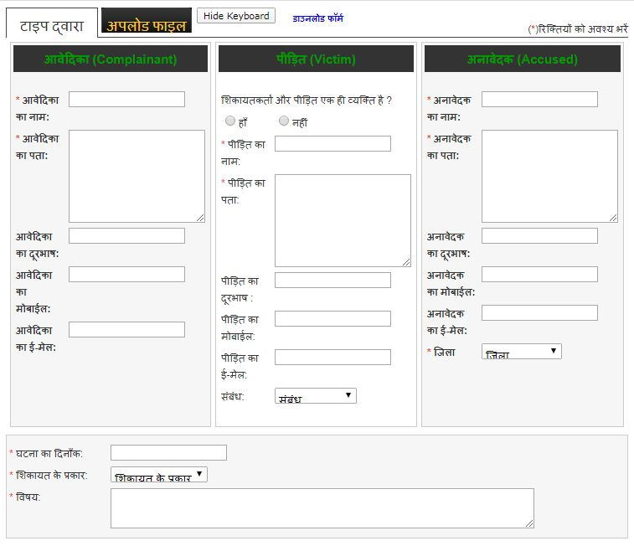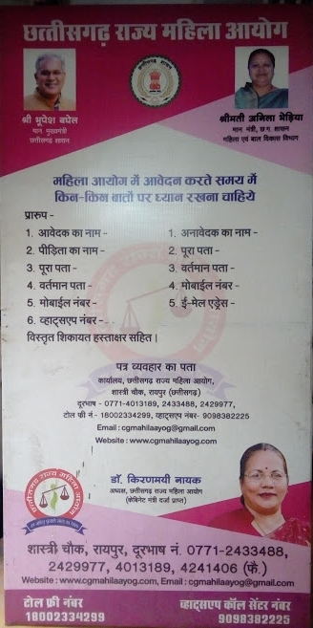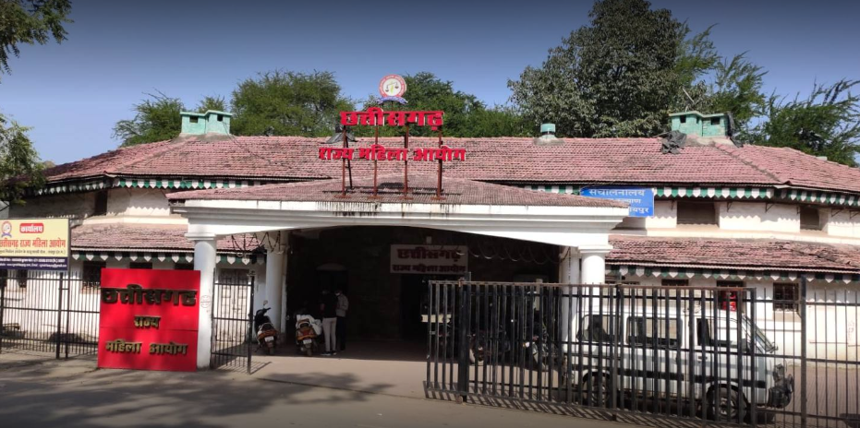

**Chhattisgarh State Mahila Ayog Complaint online**

**REPORT**

On

Ill-effects of criminal serials or web series aired on television on youth

-DIVYA DHANDE

Nowadays many shows, movies and web series are being aired on telivisions as well as on the OTT(OVER THE TOP) platforms. The aim of these shows is to entertain public and also to alert public about what type of criminal actions happened. There are various genres are available according to the public interests. There are various OTT platforms some of which are Disney+ hotstar, Netflix, Amazon Prime, Voot, MXplayer etc. .They are very affordable and on a single platform we can watch or binge many movies, web series, tv shows, reality shows .

The crime reality shows are becoming very popular among the Indian audience and at the same time leading to a scope of developing effects or various implications on the perceptions, thought process and behaviours of general viewers. The effects can be either positive or negative.The producers of the shows say that this kind of crime programs exposes the society‟s underbelly, help the viewers to stay alert in their daily life so that they can avoid themselves getting into such trouble. The aim of these shows is to warn and inform people about crimes and the effectiveness of these shows depends on how it is perceived by the viewers, say the makers of these shows. But research studies are meager to prove that making such crime shows help the public to get criminal ideas and that is harmful for others.

Viewers generally like to view the shows at given time slots so as to maintain the interest intact. However, YouTube is the second best source for the viewers to view the repeat shows. Themes like online crimes, murder mysteries, action filled with violence, domestic violence are quite popular among the viewers. No doubt that crime reality shows creates awareness on growing criminality in the society, guides people what is good and bad and keeps us alert. Yet viewers are not under impression that this would bring an easy solution or justice to all the sections of people in society. Regarding the content and presentation of crime reality viewers though agreed that manipulation happens in these shows, they expect to keep these shows more realistic with balanced approached of dramatization. The viewers feel that kids should not be exposed to these kinds of programs can install fear and lead to other psychological impacts. However, youngsters feel that 16 years is an ideal age to view these shows as young adults are more vulnerable to such crimes. While women viewers are expecting some sort of regularity in content of crime reality shows, men are contradicting this opinion. The study also proved the impact of crime reality shows on various psychological factors and opinions that lead to the construction of social reality. The viewers are under strong impression that these kinds of programmes would lead to the development of innovative criminal thoughts and ideas, and male viewers opine that these shows could satisfy certain hidden psychological pleasures like jealousy, hedonism, intoxication, sexualities etc. It has been found from the research study that there is a negative correlation with regard to portrayal of police, law and order, judiciary and forensics onscreen and the real life situation. Somehow these shows fail in boosting the morality of police and system. As explained earlier, too much of dramatization, hyped role of police, sensationalisation of the issues etc have created a negative image on the real police. In fact many respondents are neutral in their approach regarding their personal trust and belief on police.

For example , this is a real life story about a student who died because of a impact of a web series. This case is belongs to nearby my area of living i.e. Khamtarai Raipur, There is show named ‘MIRZAPUR’ which is actually entertainment purpose but the cruelity in that show manipulate some children. A 10th standard student leaving to his house after his last board examinations. There was a group of some senior students who tried to take a ragging to him by bullying him. They asked his name and he didn’t replied so they started doing the thing been shown to that web series “MIRZAPUR”. They were continued to asking him by beating him and saying “k, kha, ga….etc.”. They beat him so hard that he died. Like this case there are definitely more cases being happening daily and we can’t even imagine and know what are that and with whom its happening.

The research study also significantly proved the fear of victimization among both male and female viewers. As theorized in the concept of Mean World Syndrome developed under Cultivation Theory by George Gerbner, the viewers of crime reality show are under strong opinion that the society is getting deteriorated day by day because of growing crime rates and they can be victims of such crimes anywhere, anytime. Hence they feel that people should be very careful in dealing with situations and mingling with other. There is a lean trust even on neighbours. Also many women viewers feel they are not safe and more vulnerable to many risks at the given situations proving the fact of higher sense of vulnerability due to crime reality shows.

IN CONCLUSION, WE CAN SAY THAT THE SHOWS WHICH ARE MADE FOR US TO ALERT US AND TO INFORM ABOUT THE CRIMES, LAWS AND JUSTICE , THEY THEMSELVES UNKNOWINGLY PROVIDE NEGATIVE IMPACT ON HUMANS SPECIALLY ON TODAY’S YOUTH.

______________________________________